Exercise D result

1. I implement a global function to calculate Standard Deviation:

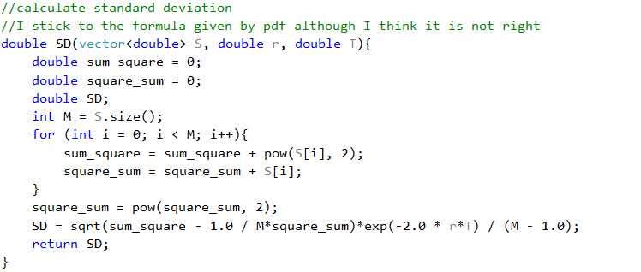

And Standard Error can be calculated based on this result.

1. We take Batch 1 as example:

When NT=100, NSIM=20000

